GRANARD MUNICIPAL DISTRICT

Corporate Affairs,
Aras an Chontae,
LONGFOIRT.

15th September 2015.

Please note change to time to 3.00 p.m.

To: Each Member of Granard Municipal District.

Dear Member,

You are requested to attend Meeting of Granard Municipal District to be held in the Granard Community Library on Tuesday, 22nd September 2015 at 3.00 p.m. to transact business, as set out on the Agenda hereunder.

Yours sincerely,
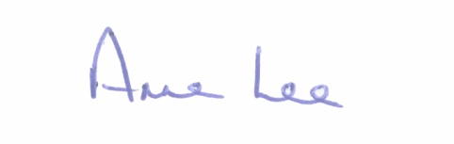

_______________
Anne Lee,
Meetings Administrator.

AGENDA

Prayer before meeting.

1. Confirmation of Minutes of the following Meetings of Granard Municipal District -

- Annual Meeting held on the 23rd June 2015.
- June Meeting held on the 23rd June 2015.
- copies enclosed.

2. Matters arising from Minutes.

3. Consideration of arrangements for payment of 2015 Community Grants - report enclosed.

4. Update on Gaigue Cross Safety Scheme.

5. Notices of Motions submitted by Councillors, as listed hereunder -

Councillor Martin Mulleady

“I propose that Granard Municipal District seek funding for a low cost safety scheme/pedestrian crossing on the Mill Road, Drumlish, from the Community Crèche/playground to the entrance of Mill Oaks Housing Estate, to alleviate speed problems and for pedestrian safety.”

“I call on Longford County Council to seek funding for a path from Hughes Shop to the Church in Ennybegs, Killoe.”

Councillor Luie McEntire.

“That new road markings are carried out on the junction at Smear Stores and the Supermarket and that car parking markings are carried out at the Health Centre.”

Councillor Paraic Brady.

“That warning signs be erected on the bend at Kilnashee, Drumlish.”

Councillor Michael Carrigy.

“I call on the Granard Municipal District to allocate 15% of the extra roads funding recently for LIS Schemes.”

I call on Longford County Council to apply for a Low Cost Safety Scheme to carry out works at Kiernans Forge in Killoe.”

“I wish to get an update on my previous motion for a pedestrian crossing on the R194 in Ballinalee.”

6. Correspondence.

(a) Letter from Minister Heather Humphreys regarding the possible acquisition by the State of Granard Motte.

7. A.O.B.

